User's Manual SR-WD002
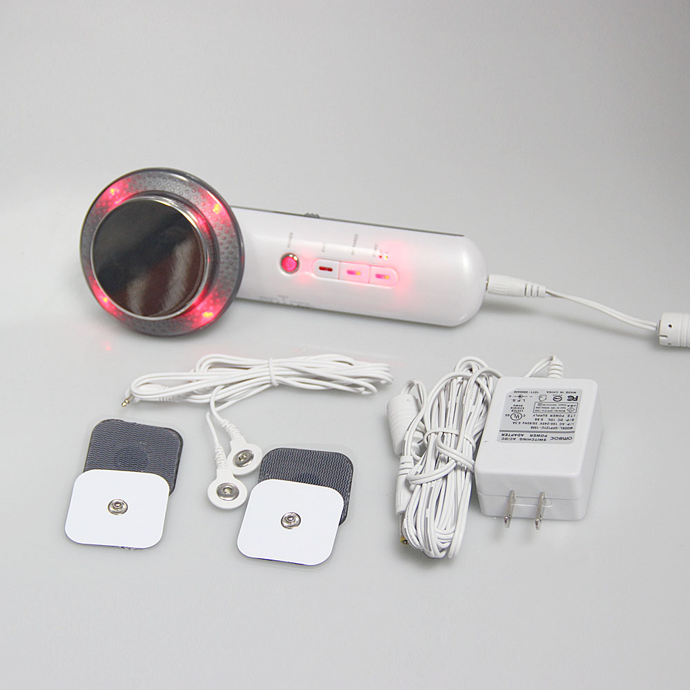

Foreword
Dear User:
Welcome to use our 3 in 1 body-slimming massager for fat blasting and pain relief, this multifunctional home massager integrates Ultrasonic, EMS bionic current and far-infrared light, which can effectively improve local fat deposit, obesity, relieve pain and tense muscle, achieving safe, comfortable, and efficient face care and body sculpting with high technology. This massager is a professional instrument which requires professional operation by a well-trained operator, incorrect operation may cause adverse consequences to the human body, so we hope that the operator read this manual in detail before start and strictly follow the instructions in the manual to operate the instrument.
We believe our high-quality products will bring you excellent returns, and our perfect after-sales service will free your worries.
Thank you!

Content
Foreword

Part I
Introduction
Advantages
Working Principle
Application and Effect
Face Care
Arms Sculpting
Body Sculpting and Massage
Waist Sculpting
Abdomen Sculpting
Legs Sculpting
Buttocks Sculpting
Shoulder and Neck Sculpting
Arms Massage
Back Massage
Waist Massage
Buttocks Massage
Legs Massage

Part II
Detailed operation
Technical parameters
Contraindications
Precautions
Troubleshooting
FAQ
Packing list
Application diagram

Part I

Introduction
The Slimming Massager can effectively dissolve fat, sculpt body, reduce local obesity, as well as relieve local muscle pain, ergonomic design provides more practical use experience with better fit, less effort, while with more obvious effect, it can not only used for body slimming, but also skin care and massage, leaving you attractive appearance. It is a home slimming instrument which can replace treatment in salon and traditional manual massage. This instrument provide solution to local obesity with easy, convenient, fast operation. No injection, no medicine, no surgery, no side effect, external use and comfortable experience.

Advantages
- Mini size, portable design, obvious effect.
- Multiple functions, achieving weight-loss, massage and care at the same time.
- Perfect combination of fat-dissolving, vibration, far-infrared light provides strong fat blasting and body shaping.
- Quickly vibrate fat, break fat cells, leaving remarkable weight-loss effect.
- Available for limbs, parts with fat deposit.
- Deep heat, strong vibration, accelerated circulation, fast remove fat from the body.
- Relieve local muscle tension and soreness by stimulating acupuncture points and massage muscles with EMS low voltage electricity.
- Ultrasonic only targets fat cells and not causing harm to other tissues, nerves, blood vessels, lymph, etc.
- Easy application, simple instructions, comfortable and painless, enjoy it at home.
- With strong penetration, far-infrared light activates water molecules, increases the oxygen content of the body, dilates blood vessels, promotes blood circulation and metabolism, and strengthens the body's resistance.

Working Principle

Ultrasonic
With strong power and high energy, when ultrasonic applying on skin, it can make the skin cells vibrate with it, producing micro-fine massage effect, changing the cell volume, thus improving the circulation of local blood and lymphatic fluid, enhancing cell permeability, improving tissue metabolism and regeneration, softening the tissue, stimulating the nervous system and cell function, making the skin lustrous and elastic. And the heat promotes skin regeneration, blood circulation and fat dissolving, leaving the effect of body slimming.

Biological effects:
There is different acoustic impedance while ultrasonic waves entering different body tissue and be absorbed locally as viscous shear stress, the absorbed energy leads to an increase in blood and tissue temperature, accompanied by the scattering process to generate radiation pressure and flow velocity beam within the blood stream. At the same time, the radiation pressure pushes the cells against the vessel wall and causes them to accumulate. When free gas inclusions and cavitated microbubbles are present in the blood, the cells are rarely destroyed, but the acoustic flow beam usually enhances the shear force, which leads to cell lysis. The cavitation effect can also produce harmful non-therapeutic biological effects. High-intensity pressure waves rupture blood cells and tissues, leading to the formation of cavities and bubbles and intensifying oscillation, which can dissolve fat and metabolize it out of the body.

EMS
EMS low-frequency bionic current concentrates and disperses electric energy according to a certain frequency characteristic, which can realistically simulate massage by human, along with point massage to achieve the endocrine regulation and fat consumption. Stimulate the subcutaneous tissue to activate cells and collagen contraction and reorganization, and create new collagen to make muscles stronger and more energetic; stimulate lymph, contract muscles, and achieve the effects of removing edema and lifting and tightening. Improve fine lines and wrinkles on the skin surface, restore skin to youthful, smooth, soft and delicate status.

Far-infrared Light
With strong penetration and radiation, remarkable significant temperature control effect and resonance effect, it is easily absorbed by the object and converted into the internal energy of the object, it is one of the rays that can penetrate into the skin and subcutaneous tissues most among all sun rays, after being absorbed by the body, it prompts the atoms and molecules of human cells to resonate, promotes fat burning, capillary expansion, accelerates blood circulation, strengthens the metabolism between tissues, increases the regenerative capacity of tissues, and improves the body immunity.

Face Care

Efficacy
- Replenish nutrients to deep layer of skin and promotes skin absorption.
- Improve skin texture, moisturize skin.
- Make skin delicate and smooth, shrink enlarged pores.
- Accelerate blood circulation and skin metabolism.
- Bright complexion, improve skin unevenness, dullness.

Indications
- People with dry skin, or whose skin is lack of nutrients.
- Rough skin, with enlarged pores.
- People with bad skin absorption or metabolism/
- People with uneven, dull skin.

Contraindications
- People in period of pregnancy, lactation, menstruation, recovery after a surgery.
- People with severe diseases, hypertension, heart disease, diabetes, severe thyroid, malignant tumors etc.
- People suffering from skin diseases and infection diseases, or experiencing skin irritation.
- People who are experiencing skin irritation, with severe sensitive skin.
- People with extensive trauma at treatment area.

After treatment
- Keep yourself hydrated and pay attention to sun protection.
- Clean face with warm water in 3 days after treatment.
- Apply mask at least 3 times a week after treatment.
- Avoid staying up late, smoking, alcohol and maintain a health daily routine.

Body Sculpting and Massage
Efficacy
- Fast fat removal, creating perfect body contour.
- Accelerate detoxification and metabolism, increase skin elasticity.
- Dissolve fat, remove cellulite, improve local fat deposit like love handles, thick legs.
- Relive local pain and local muscle tension.
- Dredge meridians, improve blocked meridians.
- Accelerate blood circulation, increases tissue regeneration and improves body immunity.

Indications
- People with love handles due to sedentary lifestyle.
- People with bingo wings and thick legs.
- People with flabby and shapeless buttocks.
- People with excessive fat on thighs.
- People with more fat on lower body.
- People with local obesity, fat deposits, causing bad-looking in clothes.
- People with unproportionate body shape, excessive weight.
- People with sore part, tense muscle.
- Fatigue caused by prolonged sitting and standing, muscle soreness and swelling.
- Limp and numb limbs.

Contraindications
- People in period of pregnancy, lactation, menstruation, recovery after a surgery.
- People with severe diseases, hypertension, heart disease, diabetes, severe thyroid, malignant tumors etc.
- People suffering from skin diseases and infection diseases, or experiencing skin irritation.
- People who are recovering from a surgery or with wounds from a recent liposuction surgery.
- People with severe varicose veins and tumors.
- People who are experiencing skin irritation, with severe sensitive skin.
- People recently had liposuction surgeries.
- Excessive aging group.

After treatment
- Keep warm, avoid cold food, or catch a cold after treatment.
- Take a shower 4 - 6 hours later after treatment.
- Drink more warm water to keep yourself hydrated and accelerate metabolism.
- Do not overeat or stay up late.

Part II

Detailed operation
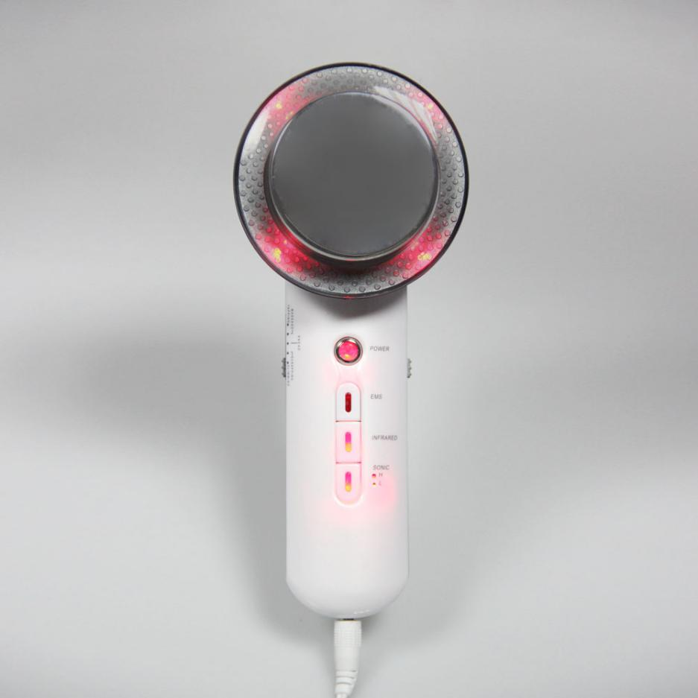

Buttons and Application Introduction
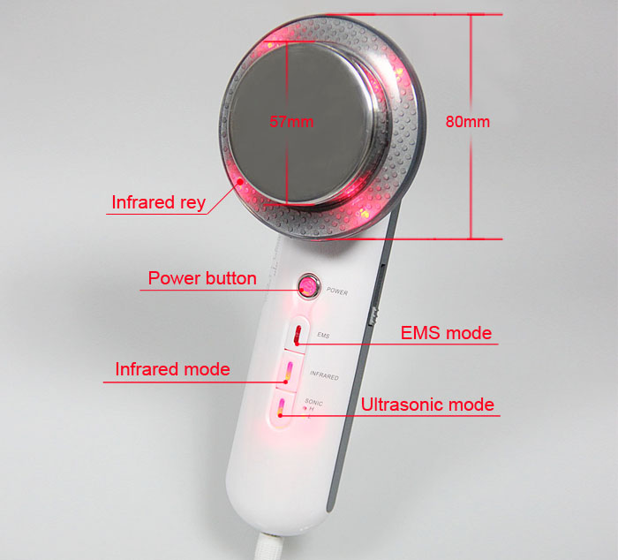

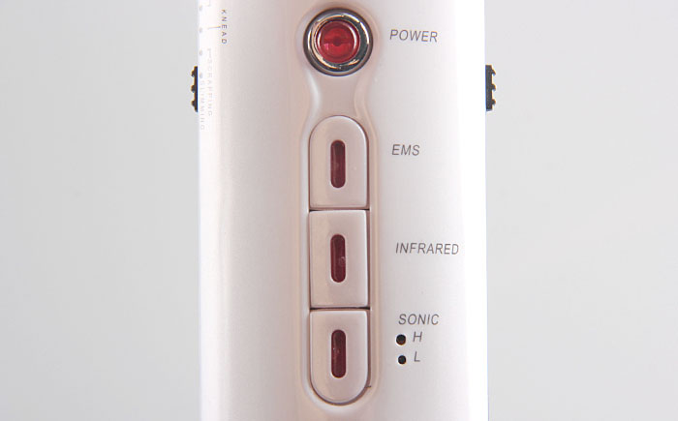
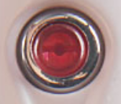On/off button, press on/off button
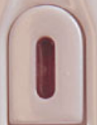EMS Button
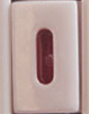Far-infrared Button
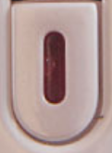Ultrasonic button, press once to switch on ultrasonic function at level L, press one more time to switch to level H, and another time to switch off.
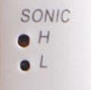Display of Ultrasonic intensity
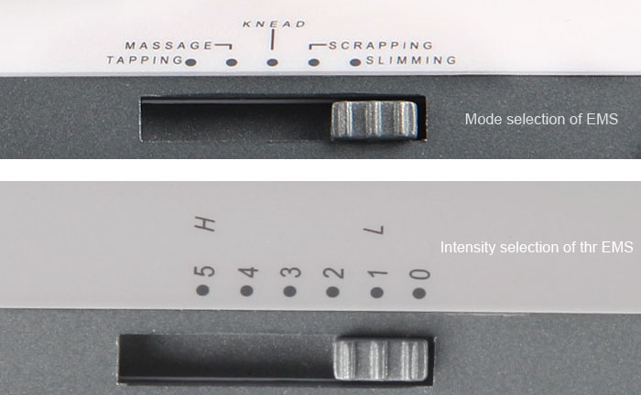

Five modes of EMS: Tapping, Massage, Knead, Scrapping, Slimming, glide the button to corresponding mode.
Tapping: for people without massage habit, or with slight fatigue, strain and soreness.
Massage: For people with obvious fatigue and strain, and enjoying massage.
Knead: For people with severe strain, fatigue and pain, and tense muscle.
Scrapping: For local edema, muscle tingling, muscle tension, and poor circulation caused by sedentary and long-time standing.
Slimming: for people with loose, sagging, inelastic, wrinkled skin and those who need to lose weight.

There are 5 levels of EMS intensity, start at 0 - 3 level for first-time use, and increase level after you getting used to it, select level according to your feeling, the higher the level, the stronger the feeling.

Technical parameters
Adaptor input power: AC100-240V
Adaptor output power:15V,800mA
Ultrasonic waves: 1Mhz,

Contraindications
Please do not use the instrument or consult your doctor before use if you:
Are pregnant and lactating women.
- With heart disease or pacemaker.
- With unhealed wound from a surgery or in the recovery period.
- Suffering from epilepsy, severe diabetes and hyperthyroidism.
- Patients with malignant tumors, hemophilia or severe bleeding.
- Suffer from skin disease or infectious diseases.
- Wearing metal jewelry.
- Have implanted metal, plastic, silicone at treatment area.
- Are sensitive to current, with wounds on the treatment area.

Precautions
- Before using the instrument, you must use a plug with a grounding pin and ensure that the power socket of the instrument is grounded.
- Make sure the voltage of the instrument is adapted. If the local power supply voltage is unstable, we advise you to add a power-matched regulated power supply between the mains and the instrument.
- Please use the designed accessories provided or advised by original manufacturer to sustain normal service life of the instrument and treatment effect.
- Do not place the instrument near strong heat, as this may affect its service life and performance.
- Remove off all the metal objects from your body to avoid unpredictable situation and affect the treatment.
- Do not use the instrument on the eyes, thyroid, parathyroid, testicles, abdomen of pregnant women and pacemaker.
- The instrument is not intended for use by patients, unless they have the permission of a doctor.
- Please turn off the power of the instrument when not in use, and make sure to turn off the general power of the instrument before leaving after daily use to ensure the safety of instrument.
- Strictly follow the instructions in the manual to use the instrument and train operator.
- In case that you are taking other weight loss drugs, it is recommended to stop the drugs for 1 to 2 months before treatment. If you want to take the treatment immediately, the course of treatment should be extended.
- Do not use the instrument with an empty stomach, and take the weight loss treatment 1 hour later after meal.
- Keep the treatment head in full contact with skin to avoid uneven heat.
- Start the treatment at lowest level of energy intensity and increase level after you get used to the treatment.
- Make sure the treatment area skin is moist, do not operate on dry skin.
- Clean the instrument with normal saline for hygienic reason and to prolong its service life.
- Avoid bone, heart, or part with thinner skin during treatment.
- Do not apply EMS patch on heart.

Troubleshooting

Instrument fails to turn on and the button lamp is off?
- Make sure the power cable is connected to a valid wall socket.
- Check if the power cord of main unit is well connected.

No feeling during treatment?
- Check if the switch is on.
- If the above methods don't work, please contact the dealer for assistance.

No feeling during EMS treatment?
- Check if the EMS patch cable is well connected with the main unit.
- Check if you have set the EMS energy intensity.

The main unit is working normally, but the handles doesn't work?
- Please unplug the power cord, and wait for 1 minute before plugging in the power cord again and restart the instrument.
- If the above methods don't work, please contact the dealer for assistance.

FAQ

Liposuction surgery or this machine?
A: The principle of liposuction is to suck out excess fat from a certain part of the body through negative pressure suction, so as to achieve the purpose of localized rapid weight loss. The effect is immediate but it is a risky surgery and requires anesthesia and recovery time. While this instrument has no risky or adverse effect, you can have slimming body easily.

Will the reduced fat get back to me?
A: It is hard for reduced fat by Ultrasonic to get back to the place it was. Since Ultrasonic reduces the fat instead of water, and the formation of fat is formed by a longer period of time before it builds up, so it is not easy to regain it.

Do I need to keep on health diet during the treatment period?
A: it would be better if you could keep on a healthy diet, since after the Ultrasonic treatment, the metabolism will be accelerated, and eating spicy, greasy, and fried food will affect the metabolism. Moderate exercise and sweating can help the body excrete metabolic waste, and the weight loss effect will be more obvious.

Can I apply Ultra Sound on the whole body?
A: NO. Ultrasound can break the fat cells, resulting in the rupture of the cell wall, the fat in the cells out, absorbed and metabolized by the lymph, so the power is very strong, the heart is more sensitive to the sound waves, because the heart is a hollow organ, subject to sound wave vibration, due to the muscle tissue and blood in the heart on the sound wave conduction is not the same, will produce back and forth reflection. This force can pull the valve away from the heart muscle. If aimed at the eyes, it can lead to retinal detachment, so avoid the area around the eyes and heart during ultrasound treatment. (Avoid waist, back and chest)

Are there any side effects of ultrasound on the human body?
A: High frequency sound wave is a non-surgical, non-invasive procedure that does not require incision or anesthesia. The process: ultrasound (mechanical wave) - cavitation blasting - ultrasound focusing.
The effect: fat shredding - fat dissolving - skin tightening - body sculpting, therefore, it only targets the low-density fat tissue and protects the high-density tissue such as blood vessels and nerves, and has no side effects on the human body. There will be slight tinnitus during the operation, which is normal and need not be worried.

Packing list
Main unit * 1
EMS Patch*2
EMS cord*2
Power cord*1

Application diagram
Parameter Settings |  | Products needed | Technique |  |  | Diagrams
Face Care: 20 - 30 minutes 3 - 5 times a week
Mode: Ultrasonic | makeup remover, facial cleanser, toner, essence, mask, instrument |  |  | - Remove makeup, 5 minutes.  - Apply toner to skin.  - Connect the power, turn on the instrument.  - Apply essence evenly.  - Set parameters, press Start button and start treatment.  - Ultrasonic application: Lift in small circle with handle from the chin to the earlobe, from the corner of mouth to the middle of the ear, from the nose to the temple, 3 times.  - Slowly move the handle from the chin to the earlobe, from the corner of mouth to the middle of the ear, from the nose to the temple, 3 times.  - Repeat the above steps on the other side.  - Move the handle in small circle on the entire forehead, 3 times.  - Apply a mask, 15 minutes.  - Remove the mask and cleanse face, 2 minutes.  - Apply toner, essence, cream and SPF.  - The end. | Technique 6  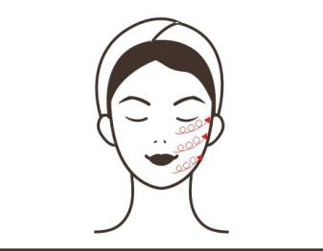  Technique 7  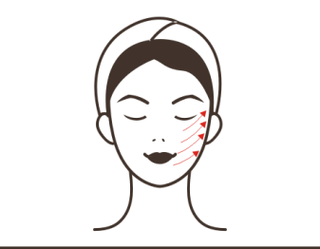  Technique 9  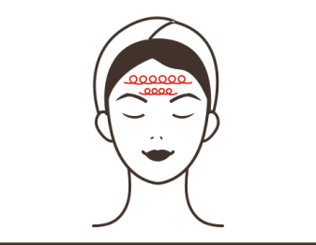
Recommended frequency:
Take 3 - 5 sessions every week, a month is a course, after 1 session the skin is moisturized, after 1 course you will find your skin is hydrated and complexion is bright, 2 courses shrink enlarged pores and make skin soft and smooth, 3 courses leave skin delicate and smooth, glowing and elastic, with usage of long period, your skin will be rejuvenated and prevent from aging.

Arms Sculpting: 35 minutes 3 - 4 times a week
Function:  Ultrasonic  EMS  EMS intensity level:  2~4  EMS mode:  Slimming |  | Towel + gel + instrument | - Wipe the arm with a wet towel, 5 minutes.  - Connect the power, turn on the instrument, 2 minutes.  - Apply gel to the arm, 2 minutes.  - Select the function you need, set intensity level (Ultrasonic).  - Ultrasonic application, move the handle in small circle on fat area of arm back and forth, 3 times.  - Move the handle on the fat deposit of arm back and forth, 3 times.  - Repeat the above application for 5 - 10 minutes.  - Pause the instrument.  - Wipe the gel off the arm with a hot towel.  - Connect the EMS patch to the main unit with the EMS cable.  - Apply the EMS patch to the fat area of upper arm.  - Select the function you need, set mode and EMS intensity.  - EMS Slimming application, 10 - 15 minutes.  - Repeat the above steps on the other arm.  - The end. |  |  | Technique 5  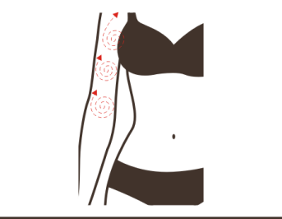  Technique 6  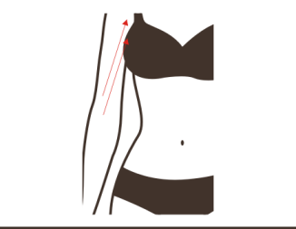
Recommended frequency:
Take 3 - 4 sessions every week, up to 4 - 5 sessions a week, a month is a course, you may not find visible change after 1st session since it takes a cycle (28 days) to metabolize fat, the same as the metabolic cycle, there will be obvious effect of fat reducing after 1 course. After 2 courses, you will find the contour of arms is getting clearer and beautiful, the 3rd course removes excessive fat, you may use the instrument on local area to achieve the effect out of your individual need.

Waist Sculpting: 25 minutes, 3 - 4 times a week
Function:  Ultrasonic  EMS  EMS intensity level:  2~4  EMS mode:  Slimming |  | Towel + gel + instrument | - Wipe waist with a towel, 3 minutes.  - Connect the power, turn on the instrument, 2 minutes.  - Apply gel to the waist evenly, 2 minutes  - Select the function you need, set intensity level (Ultrasonic).  - Ultrasonic application, move the handle in small circle on fat area of waist back and forth, 3 times.  - Move the handle on the fat area of waist back and forth, 3 - 5 times.  - Move the handle horizontally on the love handle back and forth, 5 - 8 times.  - Repeat the same on the other side.  - Repeat the above application for 5 - 10 minutes.  - Pause the instrument.  - Wipe the waist with a hot towel.  - Connect the EMS patch to the main unit with the EMS cable.  - Apply the EMS patches to the sides of waist.  - Select the function you need, set mode and EMS intensity.  - EMS Slimming application, 10 - 15 minutes.  - The end. |  |  | Technique 6  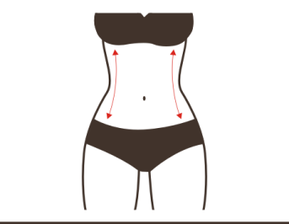  Technique 7  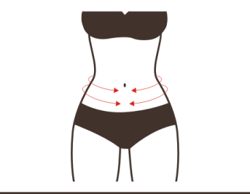
Recommended frequency:
Take 3 - 4 sessions every week, up to 4 - 5 sessions a week, a month is a course, you may not find visible change after 1st session since it takes a cycle (28 days) to metabolize fat, the same as the metabolic cycle, there will be obvious effect of fat reducing after 1 course. After 2 courses, you will find the contour of arms is getting clearer and beautiful, the 3rd course removes excessive fat, you may use the instrument on local area to achieve the effect out of your individual need.

Abdomen Sculpting: 25 minutes, 3 - 4 times a week
Function:  Ultrasonic  EMS  EMS intensity level:  2~4  EMS mode:  Slimming |  | Towel + gel + instrument | - Wipe the abdomen with a wet towel, 3 minutes.  - Connect the power, turn on the instrument, 2 minutes.  - Apply gel to the abdomen evenly, 2 minutes.  - Select the function you need, set intensity level (Ultrasonic).  - Ultrasonic application, move the handle in small circle on fat area of abdomen back and forth, 3 times.  - Move the handle on the fat area of abdomen back and forth, 3 - 5 times.  - Move the handle horizontally on the fat area of abdomen back and forth, 5 - 8 times.  - Repeat the above application for 5 - 8 minutes.  - Pause the instrument.  - Wipe abdomen with a hot towel.  - Wipe the waist with a hot towel.  - Connect the EMS patch to the main unit with the EMS cable.  - Apply the EMS patches to the fat area of abdomen.  - Select the function you need, set mode and EMS intensity.  - EMS Slimming application, 10 - 15 minutes.  - The end. |  |  | Technique 5  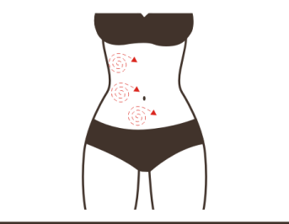  Technique 6  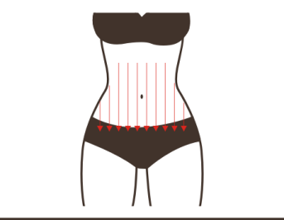  Technique 7  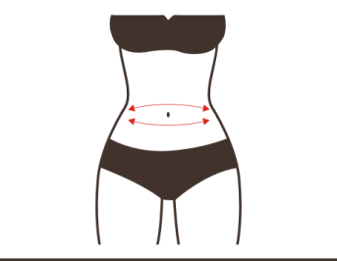
Recommended frequency:
Take 3 - 4 sessions every week, up to 4 - 5 sessions a week, a month is a course, you may not find visible change after 1st session since it takes a cycle (28 days) to metabolize fat, the same as the metabolic cycle, there will be obvious effect of fat reducing after 1 course. After 2 courses, you will find the contour of arms is getting clearer and beautiful, the 3rd course removes excessive fat, you may use the instrument on local area to achieve the effect out of your individual need.

Legs Sculpting: 20 minutes 3 - 4 times a week
Function:  Ultrasonic  EMS  EMS intensity level:  2~4  EMS mode:  Slimming |  | Towel + gel + instrument | - Wipe the legs with a wet towel, 3 minutes.  - Connect the power, turn on the instrument, 2 minutes.  - Apply gel to the fat deposit of leg, 2 minutes.  - Select the function you need, set intensity level (Ultrasonic).  - Ultrasonic application, move the handle in small circle on fat area of leg back and forth, 3 times.  - Move the handle on the fat area of leg back and forth, 3 - 5 times.  - Horizontally lift the cellulite on leg, 5 - 8 times.  - Repeat the above application for 5 - 8 minutes.  - Pause the instrument.  - Wipe thighs with a hot towel.  - Connect the EMS patch to the main unit with the EMS cable.  - Apply the EMS patches to the fat deposit on the inner side of thigh.  - Select the function you need, set mode and EMS intensity.  - EMS Slimming application, 10 - 15 minutes.  - Repeat the same on the other side.  - The end. |  |  | Technique 5  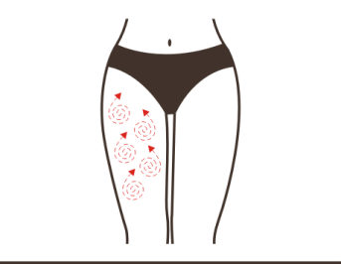  Technique 6  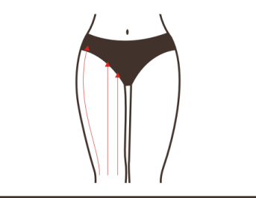  Technique 7  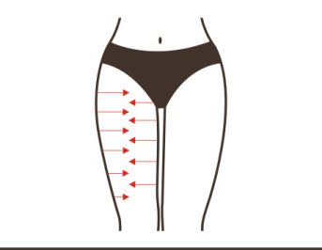
Recommended frequency:
Take 3 - 4 sessions every week, up to 4 - 5 sessions a week, a month is a course, you may not find visible change after 1st session since it takes a cycle (28 days) to metabolize fat, the same as the metabolic cycle, there will be obvious effect of fat reducing after 1 course. After 2 courses, you will find the contour of arms is getting clearer and beautiful, the 3rd course removes excessive fat, you may use the instrument on local area to achieve the effect out of your individual need.

Buttocks Sculpting: 25 minutes, 3 - 4 times a week
Function:  Ultrasonic  EMS  EMS intensity level:  2~4  EMS mode:  Slimming |  | Towel + gel + instrument | - Wipe the buttocks with a wet towel, 5 minutes.  - Connect the power, turn on the instrument, 2 minutes.  - Apply gel the excessive fat area of buttocks, 2 minutes.  - Set parameters, press Start button and start treatment.  - Ultrasonic application, move the handle in small circle on fat area of buttock back and forth, 3 times.  - Lift the fat deposit on buttocks upwards with handle, 5 - 8 times.  - Repeat the same on the other side.  - Repeat the above application for 5 - 8 minutes.  - Pause the instrument.  - Wipe buttocks with a hot towel.  - Connect the EMS patch to the main unit with the EMS cable.  - Apply the EMS patches to the fat deposit on the sides of buttocks.  - Select the function you need, set mode and EMS intensity.  - EMS Slimming application, 10 - 15 minutes.  - The end. |  |  | Technique 5  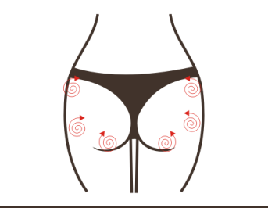  Technique 6, 9  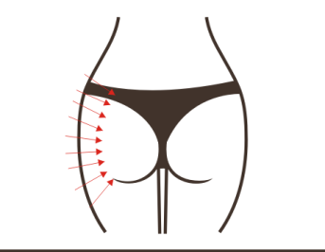
Recommended frequency:
Take 3 - 4 sessions every week, up to 4 - 5 sessions a week, a month is a course, you may not find visible change after 1st session since it takes a cycle (28 days) to metabolize fat, the same as the metabolic cycle, there will be obvious effect of fat reducing after 1 course. After 2 courses, you will find the contour of arms is getting clearer and beautiful, the 3rd course removes excessive fat, you may use the instrument on local area to achieve the effect out of your individual need.

Neck and Shoulder Massage: 20 minutes 3 - 5 times a week
Function:  EMS  EMS intensity level: 2~5  EMS mode: Massage | Instrument |  |  | - Wipe the neck and shoulder with a wet towel, 2 minutes.  - Connect the power, turn on the instrument.  - Connect the EMS patch to the main unit with the EMS cable.  - Apply the EMS patches to the Daban meridian.  - Select the function you need, set intensity level.  - Start Massage: let it work for 10 minutes.  - Move the EMS patches to the area under Fengchi point and Fengfu point, 2 minutes.  - Reset mode and intensity.  - Start Massage: let it work for 5 minutes.  - Stop the instrument and remove EMS patches.  - The end. | No diagram
Recommended frequency:
Take 3 - 4 sessions a week, you may use it every day as you wish, a course is made up of 10 sessions, after 1 session your shoulder and neck are relaxed and the pain is relieved, 1 course keep reliving pain and muscles, you will gain more energy, 2 courses completely release your back from pain, and muscle is relaxed, you will have better sleep, long-term consistent use can prevent muscle stiffness, enhance mental strength and strengthen immunity.

Arms Massage: 20 - 30 minutes 3 - 5 times a week
Function:  EMS  EMS intensity level:  2~5  EMS mode: Massage | Instrument |  |  | - Wipe the arms with a wet towel, 2 minutes.  - Connect the power, turn on the instrument.  - Connect the EMS patch to the main unit with the EMS cable.  - Apply gel to the inner and outer side of arm.  - Apply EMS patches to the inner and outer side of upper arm.  - Select the function you need, set intensity level.  - Start Massage: let it work for 10 minutes.  - Move the EMS patches to the muscles on lower arms, 2 minutes.  - Reset mode and intensity.  - Start Massage: Let is works for 5 minutes.  - Stop the instrument and remove EMS patches.  - The end. | No diagram
Recommended frequency:
Take 3 - 4 sessions a week, you may use it every day as you wish, a course is made up of 10 sessions, after 1 session your arms are relaxed and the fatigue is relieved, 1 course keep relieving soreness and numbness, you will gain more energy, 3 courses completely release your arms from pain, and skin is tightened, consistent use can prevent arm pain and sagging skin.

Back Massage: 20 minutes 3 - 5 times a week
Function:  EMS  EMS intensity level:  2~5  EMS mode: Massage | Gel + instrument + towel |  |  | - Wipe the back with a wet towel, 2 minutes.  - Connect the power, turn on the instrument.  - Connect the EMS patch to the main unit with the EMS cable.  - Apply gel to the sore part on back.  - Apply EMS patches to the Jianzhong points (2 sides of neck hump)  - Select the function you need, set intensity level.  - Start Massage: let it work for 10 minutes.  - Move the EMS patches to the Tianzong points (the concave area between the scapula and the armpit).  - Reset mode and energy intensity.  - let it work for 5 minutes.  - Stop the instrument and remove EMS patches.  - The end. | No diagram
Recommended frequency:
Take 3 - 4 sessions a week, you may use it every day as you wish, a course is made up of 10 sessions, after 1 session your back is relaxed and the fatigue is relieved, 1 course keep relieving the back pain, you will have much relaxed back, 3 courses can dredge meridians and improve sleep, consistent use can promote metabolism and improve body sub-health.

Waist Massage: 20 minutes 3 - 5 times a week
Function:  EMS  EMS intensity level:  2~5  EMS mode: Massage | Gel + instrument + towel |  |  | - Wipe the waist with a wet towel, 2 minutes.  - Connect the power, turn on the instrument.  - Connect the EMS patch to the main unit with the EMS cable.  - Apply the EMS patches to the sore parts on the both sides of lumbar spine.  - Select the function you need, set intensity level.  - Start Massage: let it work for 10 minutes.  - Move the EMS patches to the Baliao area.  - Reset mode and energy intensity.  - Start Massage: Let is works for 5 minutes.  - Stop the instrument and remove EMS patches.  - The end. | No diagram
Recommended frequency:
Take 3 - 4 sessions a week, you may use it every day as you wish, a course is made up of 10 sessions, after 1 session your waist is relaxed and fatigue is relieved, 1 course keep relieving waist pain, 3 courses completely release waist from pain and balance endocrine, and restore regular menstruation, consistent use can prevent lumbar muscle strain and weakness.

Buttocks Massage: 20 minutes 3 - 5 times a week
Function:  EMS  EMS intensity level:  2~5  EMS mode: Massage | Gel + instrument + towel |  |  | - Wipe the buttocks with a wet towel, 2 minutes.  - Connect the power, turn on the instrument.  - Connect the EMS patch to the main unit with the EMS cable.  - Apply EMS patches to the sore part of buttocks where need  - Select the function you need, set intensity level.  - Start Massage: Let it works for 10 - 15 minutes.  - Stop the instrument and remove EMS patches.  - The end. | No diagram
Recommended frequency:
Take 3 - 4 sessions a week, you may use it every day as you wish, a course is made up of 10 sessions, after 1 session your buttocks are relaxed, 1 course keep relieving the buttocks soreness and discomfort, 2 courses accelerate blood circulation and drain out toxin, relive menstrual pain, 3 courses completely release buttocks from pain and improve sleep, consistent use can prevent and improve gynecological disorder.

Legs Massage 20 - 30 minutes 3 - 5 times a week
Function:  EMS  EMS intensity level:  2~5  EMS mode: Massage | Gel + instrument + towel |  |  | - Wipe the back with a wet towel, 2 minutes.  - Connect the power, turn on the instrument.  - Connect the EMS patch to the main unit with the EMS cable.  - Apply the EMS patches to the sore part on both side of thighs.  - Set parameters, press Start button and start treatment.  - let it work for 10 minutes.  - Move the EMS patches to the lower legs.  - Reset mode and energy intensity.  - Start Massage: let it work for 5 - 10 minutes.  - Stop the instrument and remove EMS patches.  - Repeat the same on the other side.  - The end. | No diagram
Recommended frequency:
Take 3 - 4 sessions a week, you may use it every day as you wish, a course is made up of 10 sessions, after 1 session your legs are relaxed, 1 course dredges meridians, accelerate blood circulation and relive leg pain, 3 courses prevent edema and varicose veins, long-term use can regulate nerves and improve immunity.

