Unoisetion 3D RF BIO Vacuum Slimming Machine

Model:YH-5403S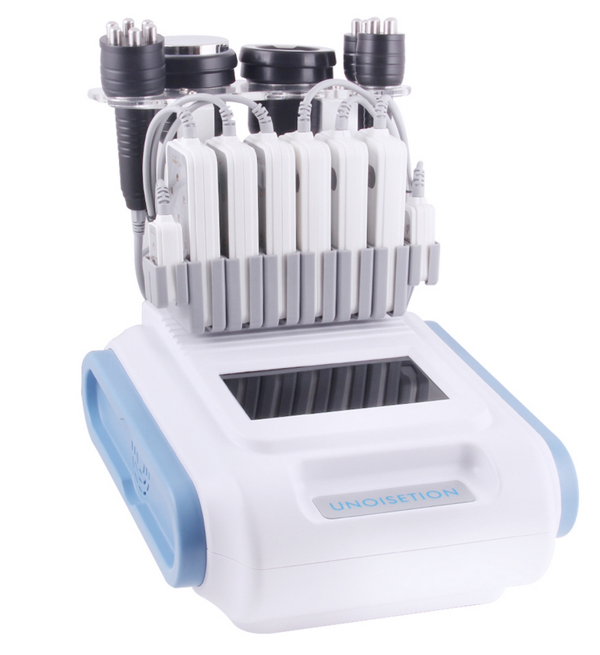

Chapter 1: Safety Warnings
- Electricity & Machinery Safety
1.The machine is either 110V And 220V. So whatever the voltage u can use before starting the machine.
2. Please keep the voltage at stable condition.

- Contraindication Safety
1. People with heart disease, high blood pressure, or configured cardiac Pacemaker.
2. People with acute inflammation, asthma, deep vein thrombosis, thyroncus, cancer.
3. People with hemorrhagic diseases, trauma or who is bleeding.
4. Pregnant women
5. Medical plastic artificial or metal parts inside the body such as metal teeth or silicone breast implants.
6. People with abnormal immune system.
7. People with numb or insensitive to heat.
8. If you are feeling unwell, Prohibited in the ears, nose, eye throat and do not use this device in advance and tell your doctor.
9. Children under 12 years old are not allowed.

- Treatment Safety
1. Treatment Time is less than 30mins/Body Part/Each Treatment.
2. The energy setting is from low to high gradually which should be subject to skin comfortableness for different people.
3. The patient had better wear the protective eye glasses.
4. If you cannot tolerant heat or uncomfortable, please stop the treatment in advance and turn to your doctor for help.

Chapter 2: Installment and Use
I .Working Condition
Using at normal temperatures and pressure. Please do not stay in too cold, too hot, too
dry and too wet

II. Technical Parameters

Power supply Input:100V-240V
Power :<=190W

Cavitation RF Head
Ultrasound Frequency: 35 - 40 Khz
Ultrasound Power: 30 - 60 w/cm2

RF Frequency: 6 - 10 Mhz (Max.)
RF Power: 100 J/cm3
RF Output: Series / Pulse
Pulse Re-cycle Time: 0.3S

Sextupolar 3D Smart RF
Freqeuncy:1MHz
Power:50W

Quadrupole Vauum 3D Smart RF
Freqeuncy:1MHz
Power:50W
Vacuum: <-80kPa
Pressure: >250kPa
Air flow: >10L/minute
Noise level: <70dB (30cm away)

Quadrupole 3D Smart RF & BIO
Freqeuncy:1MHz
Power:30W
Vacuum: <-80kPa
Pressure: >250kPa
Air flow: >10L/minute
Noise level: <70dB (30cm away)

Bipolar SMART RF & BIO
Freqeuncy:1MHz
Power:10W
Vacuum: <-80kPa
Pressure: >250kPa
Air flow: >10L/minute
Noise level: <70dB (30cm away)
Timer: 30 minutes adjustable

Laser wavelength: 635nm ~650nm
Energy output :64 x 5mW =320mw
Mains power output: 10

- Program Setting

- Use the red power button to start the machine, the screen will show AS BLOW.
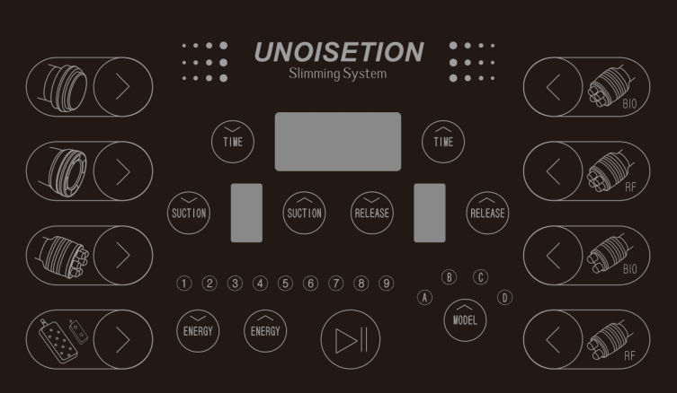

- 40K Cavitation
- Press  button to enter into 40k unoisetion function
2. Please click   to set working time.
3. Please click  to increase or decrease the ENERGY
4. Please click  to chose working model.
5. Please click  to start or pause function.
6. Please click to stop function.

B. Body Vaccum & RF
1 Press  button to enter into Body RF Vacuum operation display as bellow:

2. Please click to set working time.
3. Please click to increase or decrease the ENERGY
4. Please click to set the time for the suction and release.
4. Please click to chose working model.
5. Please click to start or pause function.
6. Please click to stop function.

7.Pls adjust 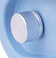 to control power of suction.
C. BODY RF
1. Press button then login BODY RF operation display as bellow:
2. Please click to set working time.
3. Please click to increase or decrease the ENERGY
4. Please click to chose working model.
5. Please click to start or pause function.
6. Please click to stop function.

D. Face RF&BIO
1. Press 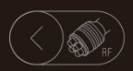button then login Face Radio Frequency.
2. Please click to set working time.
3. Please click to increase or decrease the ENERGY
4. Please click to chose working model.
5. Please click to start or pause function.
6. Please click to stop function.

7. Press button then login Face Radio Frequency.
8. Please click to set working time.
9. Please click to increase or decrease the ENERGY
10. Please click to chose working model.
11. Please click to start or pause function.
12. Please click to stop function.
E. Eye Radio Frequency
1. Press 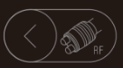 button then login Face Radio Frequency.
2. Please click to set working time.
3. Please click to increase or decrease the ENERGY
4. Please click to chose working model.
5. Please click to start or pause function.
6. Please click to stop function.

7. Press  button then login Face Radio Frequency.
8. Please click to set working time.
9. Please click to increase or decrease the ENERGY
10. Please click to chose working model.
11. Please click to start or pause function.
12. Please click to stop function.

E. Lipo laser
1. Press  button then login Face Radio Frequency.
2. Please click to set working time.
3. Please click to increase or decrease the ENERGY
4. Please click to chose working model.
5. Please click to start or pause function.
6. Please click to stop function.

After use the all function. Can use lipo laser to keep your result.
BIO FUNCTION: Operation the same RF function.

About Treatment
- Abdomen, thigh, buttock, arms slimming
Please clean the skin and then put the ultrasound gel on the treatment area, then turn on the machine, set the time and energy. Please set the energy from low to high to get the best comfortable temperature, then follow this steps:
1. Use the Body RF head 5 mins
2. Use the unoisetion 40k cavitation head 20-25min
3. Use the Body RF Vacuum head 10-15min
4. Use the Body RF head 15~20 min.
5. Use Lipo lasr pads around 25~30 min.

Work time: 2-3 times/ week
- Face, eyes around, neck skin lifting:
Please clean the skin and then put the rf gel on the treatment area, then turn on the machine , set the time and energy, pls set the energy from low to high to get the best comfortable temperature, then follow this steps:
1. Use face radio frequency head for face for 15-20 min
2. Use eye radio frequency head for eye around for 10-15min
Work time: 2-3 times/ week
BUTTOCKS
ILLUSTRATIN of OPERATION
FACE
Treated time: 30 minutes
Massage the mandible center in circles to produce deep heat.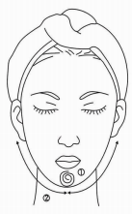
2. Massage lower jaw in lines.
3. Massage the triangle zone of both sides of the face in circles.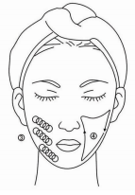
4. Massage from jaw to angulus oris to ear in lines.
THIGH
Treated time: 30 minutes
1. From down to upper, pushing to the groin to dredge the lymph.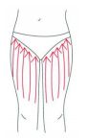
2. From down to upper, circling push by anticlockwise can help decomposing fatness.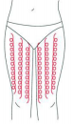
3. Also can push by come-and-go to decompose fatness.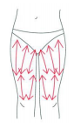
4. Pull from the knee and muscle texture to upper, can improve the curve.
Treated time: 20 to 30 minutes
1. Along the lymph direction, pulling to the waist.
2. From upper to down, by anticlockwise gesture, pull come-and-go.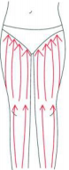
3. Along the muscle of arm, pull up to lift and tight the muscle. 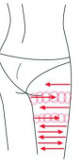
BACK
Treated time: 20 to 30 minutes
1. First by come-and-go, pushing the bladder nerve 2 to 3 times.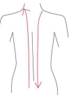
2. Circling by anticlockwise to stimulate the underarm lymph node.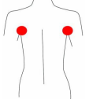
3. On the back, by anticlockwise circling, can help to decompose the fatness.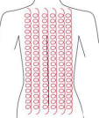
4. Using lymph drainage gesture, pull the toxin to the lymph node, can help improving the back curve.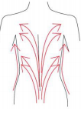
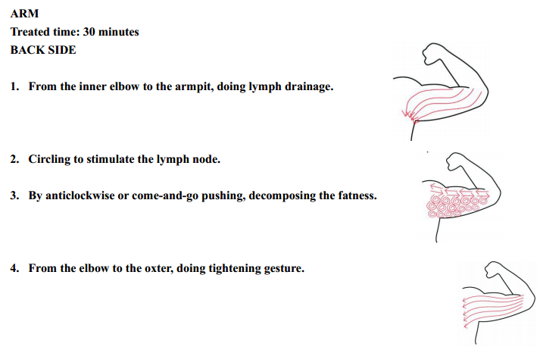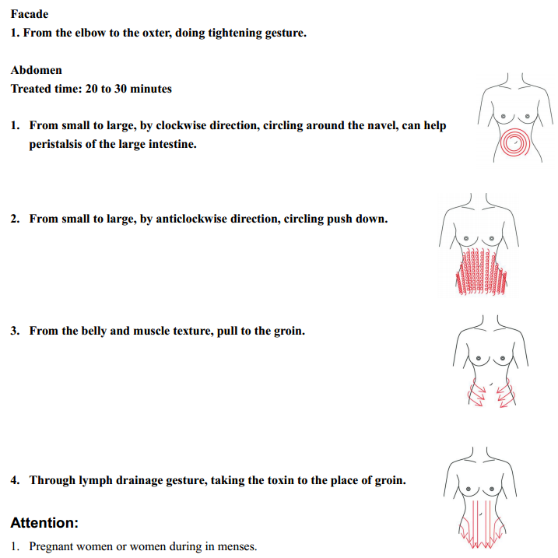
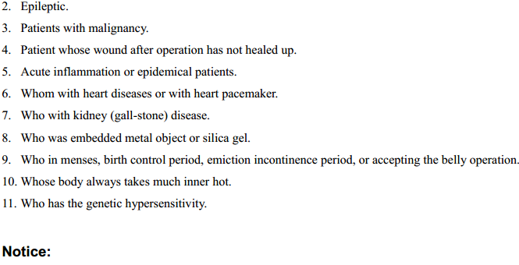
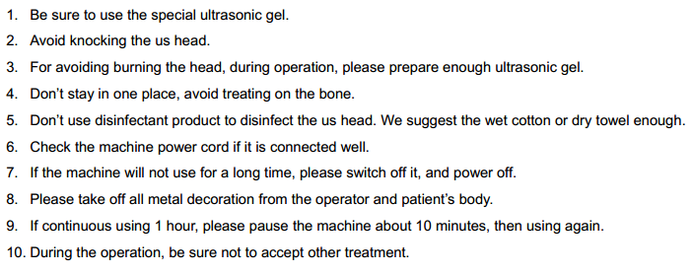

PS:Here is the link of the operation video for unoisetion cavitation machine,
If you perfer,download it for refer .

http://v.youku.com/v_show/id_XOTY2MDc4OTg4.html?firsttime=0&from=y1.4-2

