USER MANUAL

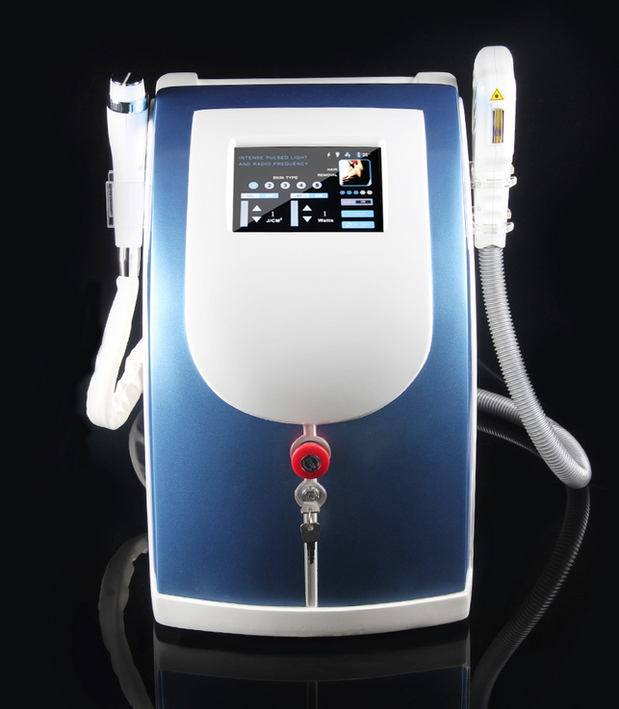

—Please read the instructions before use！

Ⅰ.Brief Introduction
E-light applies three core technology, IPL, RF, and epidermis cooling. It combines the advantage of IPL and RF, in one hand, the skin absorbs IPL energy selectively, and the skin also absorbs RF energy, on the other hand, the RF-surface-touch cooling technology removing the discomfort and complications by high heat of IPL. Therefore, the effect and safety of E-light makes a breakthrough.

1. Principle
Applying the technique of IPL and Bi-polar Radio Frequency, the equipment acts on the entire skin corium and connective tissue, stimulates the collagens of different depth to realign and grow, then gets treatment effect. Bio-polar RF release energy at the same time, with the selective absorption for the skin to light energy, various pathological tissues of corium and epidermis creates Photothermolysis effect. Since light energy is far below conventional IPL, the pigment tissue and vascular pathological tissue of the corium and epidermis would absorb more energy without injuring the epidermis, and then remove these pathological tissues better and get the effect.

2. Application：
1. Hair removal (including dark skin);
2. Skin rejuvenation

3. Acne treatment;
4. Removing freckle, age spots, sun spots, pigmentation troubles, etc;
5. Removing red face, red capillary, and bottle nose.

3. System Self-checking
The circuit of system entering the self-checking situation when the machine starts, leave the machine carry on the self-checking for 5-10 seconds, then continue the operation.

4. System Classification
Electric shock protection：Grade1
BF Grade
Corrosion prevention liquid：ordinary
Do not use the machine in the environment mixed of flammable narcotic and air or nitrogen oxide mixture.

5. Equipment Consist, Specification, & Accessory List
1. Equipment Consist:
1.1. Mainframe
A. Power supply system
B. Microcomputer system
C. Monitor
D. Cooling System
1.2. E-light Handpiece
A. Intense pulsed light source, xenon lamp
B. Reflector and filter
C. Sapphire wave guide

2. Technique Specification
● IPL Power: 800W
● RF Intense Electric Energy: 5MHz
● Light Energy: 1-50J/cm2
● Pulse Amount: 1-6
● Pulse Width: 1-10 ms
● Pulse Delay: 1-100 ms
● Repeat frequency: 1-4s
● RF working time: 50-2500 ms
● Spot size: 8x40mm
● N.W.: 35kg
● Voltage: 110V~220V±10%, 50~60Hz

3. Equipment Structure
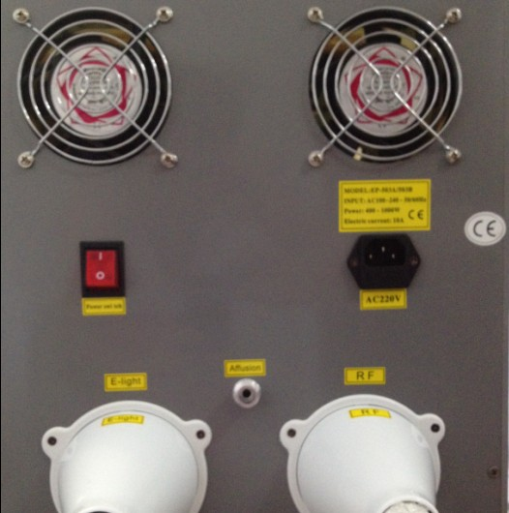

handle connector

- Accessory List

No. | Item | Unit | Qty | Remark
1 | Main frame | set | 1 | in the main case
2 | E-light Handpiece | pc | 1 | in the lateral foam box
3 | RF Handpiece | pc | 1 | in the lateral foam box
4 | Filters | pc | 5x2 | in the filter box
5 | Power Lead | pc | 1 | in the lateral foam box
6 | Key Switch | pc | 2 | in the filter box
7 | Goggles for Operator | pair | 1 | in the lateral foam box
8 | Goggles for Patient | pair | 1 | in the lateral foam box
9 | Spare Plugs & fuses | pc | 2 | in the lateral foam box
10 | Water funnel | pc | 1 | in the lateral foam box
11 | User Manual | pc | 1 | in the lateral foam box

Ⅱ.Standard Treatment Process
2.1 Form filling
Fill in the blanks of the Client File, confirm the treatment program, and remind the client pay attention to some points before and after treatment.
2.2 Face cleaning
Clean the face with gentle face cream for 3 minutes.
Remind: clean the hands of operator and the handpiece with
bromogeramine.
2.3 Preheating
Start the equipment after face cleaning; preheat for not less than 3
minutes (without lighting the xenon lamp).
2.4 Shaving
Shave the unwanted hair of the treatment area(2 minutes).
2.5 Gel coating
Coating the gel evenly (2-3mm) on the skin.
Effect：light guide, cooling, anaesthetisin.
Attention: no coating on eyes, eyebrows, lips.
2.6 Eye protection
Operator: wear the safety goggles.
Patient: close the eyes, wear professional safety goggles or cover the eyes with eye patch.
2.7 Allergic test
Emit 2 or 3 light spots in the bottom of ears in safe parameter, observe for 3 minutes.
Effect: do not continue to operate if there is an allergic phenomenon.
2.8 Operation
Carry on the operation with a suitable parameter to the patient.
ATTENTION:
2.8.1 Inform the patient that there will be a slight pricking in operation before operating, to avoid panic.
2.8.2 Start the operation with a low energy grade; adjust the parameters in operating while asking the feeling of the patient.
2.8.3 Move the light spot by one spot overlapping the upper 1/3 part of the previous spot.
No emitting one area repeatedly, otherwise may cause inflaming or burns.
2.8.4 The handpiece should touch the skin vertically, no over pressing or leaving the skin.
2.8.5 Observing the reaction of skin while operating.
2.9 Cold compress
Keep gel coating for 20 minutes after operation ending; carry out cold compress in obvious slight reddish reaction till reddish fading away.
2.10 Cleaning
Clean the gel with cold water, coat corresponding cosmetics.
2.11 Treatment Course
Skin Rejuvenation Program: 30-45 days/time (4 times/course)
Hair Removal Program: 2-3months/time (3times/course)
2.12 Special reminding
2.12.1 Ask the client before treatment: is there a allergic or not; is there a bad reaction before for similar operation; fill the Client File concretely. Adjust the parameters on the basis of full acquaintance concretely. Adjust the parameters on the basis of full acquaintance of the condition of patient. Inform the patient the possible reaction in operation before operating.
2.12.2 In large area treatment or long time continuous operating, the water inside the equipment will warm up and the handpiece will be hot, interrupt the operation to refresh the water or leave the water cool down to continue operating.
2.12.3 Refresh the circulating water in one month; use purified water or medical distilled water.

Ⅲ.Operation Instruction
3.1 Before starting the machine
3.1 Accessories connecting：
3.1.1 Connect the handle and filters:
3.1.1.1. Put the E-light handle on the hanger
3.1.1.2. Connect the E-light handle to the connecting port on the back board of the machine tightly.
3.1.2 Check the water holes of the backboard, make sure the water outlet hole is plugged well.
3.2 Water infusing:
3.2.1 pull out the plug of the water inlet hole，insert the water funnel
3.2.2 infuse water till water spill out from the spillway hole.
3.3 Checking
3.3.1 Make sure there is no water leaking;
3.3.2 Make sure there is no moisture or wet for electricity connecting parts;
3.3.3 Make sure the key switch is in the off position;
3.3.4 Make sure the emergency stop switch is in the on position.
3.4 Starting the equipment
3.4.1 Connect the power cord, turn on the key switch;
3.4.2 Double confirm there is no leaking of water circulation, fold the protective cover by turning it right.
3.5. Debugging
3.5.1. Make sure water and electric circuit is correct connected; then turn on the power to start the machine.
3.5.2. Turn on the master power switch on the backboard;
3.5.3.Turn on the emergency switch (clockwise turn) in the front side of the mainframe
3.6. Operation
Enter operation condition after debugging and no abnormalities found.
3.6.2. Treatment Program Selecting Interface

Welcome Interface

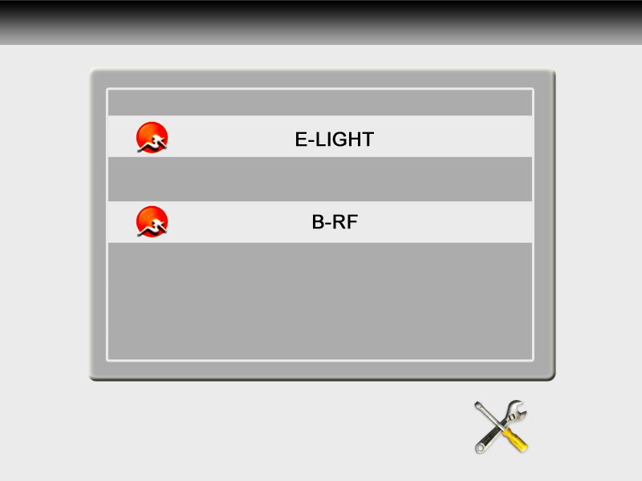

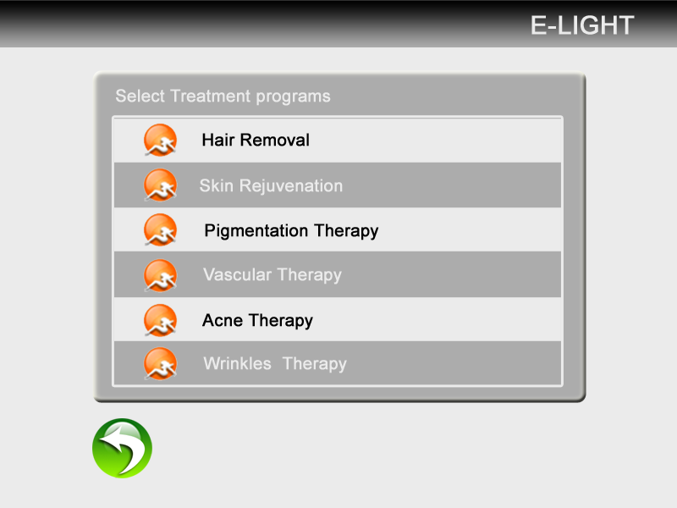
There are 6 treatment programs that could be selected:
a. Hair removal
b. Skin rejuvenation
c. Pigmentation Therapy
d. Vascular Therapy
e. Acne Therapy
f. RF: Wrinkles Therapy
Select different treatment programs by clicking.
3.6.3. Treatment Program Operation Interface

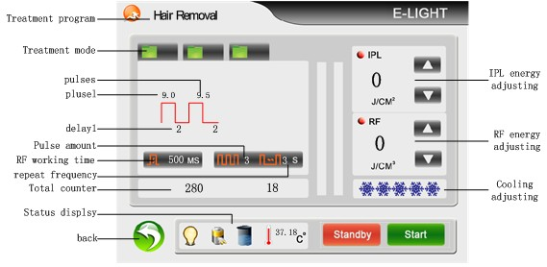
current treatment program
3 different groups of saved parameter setting.
Click , system will enter into the saved parameters of mode 1
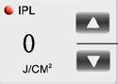 IPL energy display
Click and to increase or decrease IPL energy.
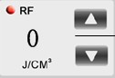 RF energy adjusting
cooling degree adjusting
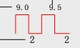
Pulse1：working time of the first pulse, 1-10ms adjustable.
Pulse 2 and Pulse 3：sub pulse width, 1-10ms adjustable.
Delay1: 1st pulse delay, interval between the 1st pulse and 2nd pulse.
Delay 2 and Delay 3: interval between two pulses.
RF working time, 50-2500ms adjustable.
Pulse amounts
interval between two spots, 1-4s adjustable.
 back
 water circulating status
 lamp status
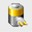 charging status
counter of shots for the current treatment
standby, click standby, the lamp will be lightened off. Click standby when treatment finish to turn off the handle
ready, click ready, the lamp of the handle will be lightened up, and light will be simmered by press the button on the handle

3.6.4. RF Operation Interface
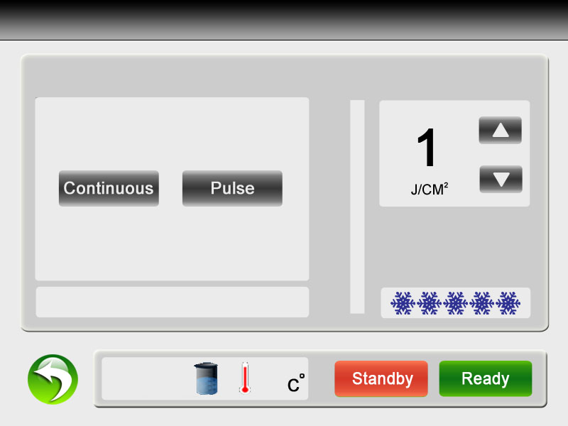
3.6.4.1 Usage of RF handle.
a. Coating the gel evenly (1mm) on the treatment area.
b. Chose different probes for different treatment area.
15mm: eyes, 20mm: forehead, face; 30mm: face, body
c. cling the probe to the skin rightly.
Attention:
a. Do not press the blue button before the probe clinging the skin.
b. Both of the two polars (two parts on the probe) must cling the skin together when operating.
c. When the operation finishes, release the blue button first, then move the probe out of the skin.
3.6.4 System Setting interface
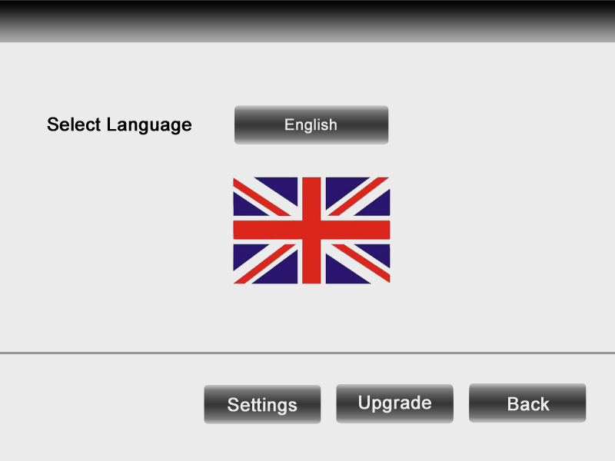

3.7 Treatment Advice
3.7.1 Hair Removal: Strong pain, follicular orifice will become a little
reddish, with a burning smell. Caution for arms, lips, and legs hair removal; avoid pigmentation by over high energy. According to the growing period of hairs, growing period- maturation period-rest period, 3 times of treatment will remove the hair completely.
Parameter control: Long pulse width, long interval, suitable energy.
3.7.2 Skin rejuvenation: Strong pain under the patient limit, reddish; redness disappear in 10 minutes. No suggesting repeat operation.
Parameter control: Long pulse width, long interval, high energy.
3.7.3 Acne scar: Patient would have a strong pain (under the limit of patient). Pigmentation will decline in 3-7 days.
Parameter control: Long pulse width, short interval, high energy.
3.7.4 Vascular, redness: Using high pulse width on the basis of easing the skin.
Parameter control: Long pulse width, long interval, suitable energy.
3.7.5 Freckle, pigmentation: strong pricking for the first treatment (under the tolerance of the patient). One minute after receiving emitting, there will be slight reddish, which will fade away in 10 minutes, (for someone special, maybe 30 minutes). Punctuate pigment will appear on the surface of skin and will be metabolized in 3-7 days.
Parameter control: Long pulse width, short interval, medium energy.
Special Attention:
For the sensitive and dark skin, there might be delayed reaction in
24-48 hours, therefore do not raise the energy casually. Adjust the parameter value according to the whiteness of skin. The whither, the higher endurance of the skin is. For dark skin, please pay more attention to use long interval and suitable energy of parameter value.
Ⅴ.Safety Notice

4.1. Safety of E-light
The equipment takes maximum consideration of the safety of both operator and operatee in the designing, the following are some safe measures of it:
- Circuit self-checking after machine starting;
- Using filter/light guide crystal, strong pulse light comes out only
- Designed with independent safety circuit, electricity could be shut
down automatically when the IPL power is to high;
- Emergency stop switch, shut down the power in emergency;
- Key switch to avoid starting the machine by any people;
- Use high quality engineering plastic frame, preventing electricity creepage.
【Alarm】
All strong pulsed light device may cause hurt by improper handling. Operators should keep vigilant and take necessary protection measures according to the manual.
Patient: Carry out the treatment in the professional treatment room; take effective eye protecting measure;
Operator: wearing protective glasses;
Treatment room：marked the treatment room clearly with in operating of IPL.
To ensure to the safe use of the equipment, please read the following instructions carefully.
- No one except technician authorized by the manufacture could dismantle or repair the equipment, especially for the power source, handle; high voltage electricity inside;
- Voltage rating: 220V;
- Maintaining the equipment after disconnecting the power cord;
- Keep the handle clean all the time; do not let the gel leaking into the handle;
- In case leaking of the handle, do not start the equipment; already started, turning off immediately;
- No emitting light to one area repeatedly, otherwise may cause inflaming or burns, and may leave pigmentation.
【Alarms of Strong IPL】
- IPL may hurt the eye or cause burns or fire, take all necessary prevention measures before operating;
- Emitting too much light to one part may burn the skin which may cause pigmentation;
- Do not watch the IPL light directly from the handle even wearing protective glasses;

4.2. Electricity & Machinery Safety
- Keep all the boards closed, open the board may bring danger;
- There is high voltage electricity inside, some parts still carry
electricity even after turn off the power, therefore, do not dismantle the backboard without under supervising by our technicians;
- Do not move the equipment by pulling the handpiece;
- Do not use the equipment in inflammable and explosive environment;
- Do not use alcohol or acetone before treatment;
- Do not start operating before the handpiece dry enough after clean the handpiece or other parts of the equipment.

Ⅵ.TABOO
The following people are not suitable to be operated by the machine:
1. pregnant, high blood pressure, heart attack, diabetic;
2. allergic to IPL;
3. open wound parts;
4. people who could not avoid strong sun light;
5. scar, birthmark, or mole higher than the skin.

Ⅶ.Attentions After Treatment
1. Not using irritative makeups;
2. No hot water face wash or sauna in 7 days;
3. No stimulating food or pigmentary food as chocolate, coffee; no smocking; no drinking;
5. No scratch in case of scabbing;
6. Make a water replenishing care in 10 days.
Ⅷ. Warranty Policy
The warranty of equipment is one year from the date of supply. During the warranty period, we undertake to repair free for the equipment supplied against all manufacturing and workmanship defects.
The standard of operation and environment should comply with the product specification and user manual.
The warranty does not extend to any equipment that:
a. Malfunctions caused by abused operation
b. Malfunctions caused by other artificial factors like move or tear down in proper motion, or collision, etc.
c. Malfunction caused by uncontrollable natural force
d. Energy reduce caused by wet environment and dust
e. Consumable parts of the equipment: handpieces.

Operation Steps
Face
The first step:Stretch

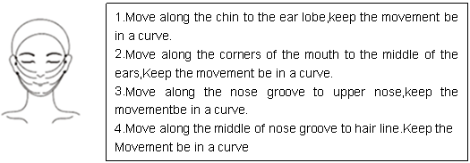
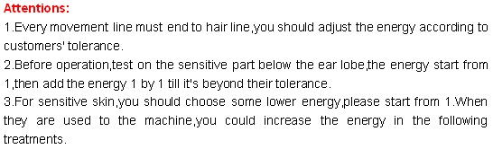

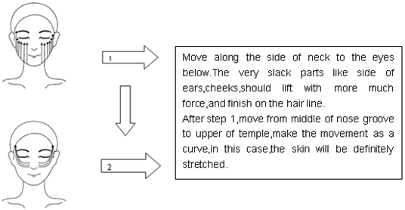

The second step:Lifting

The third step:Sizing
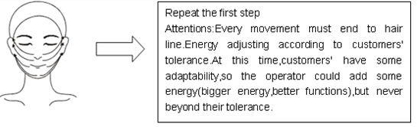

The four step:Beautify
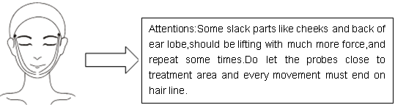

Nasolabial sulcus
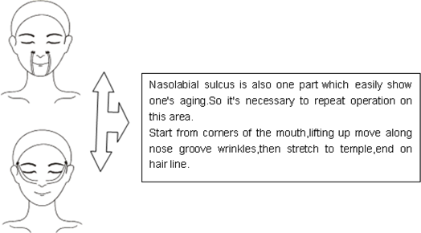

EYE
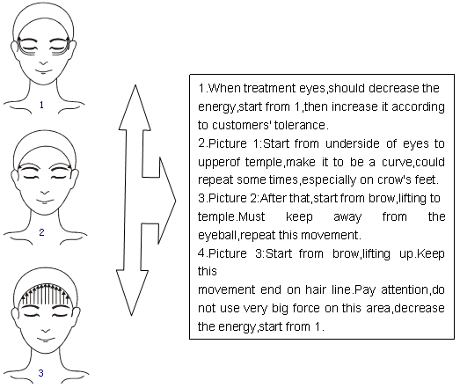
Forehead
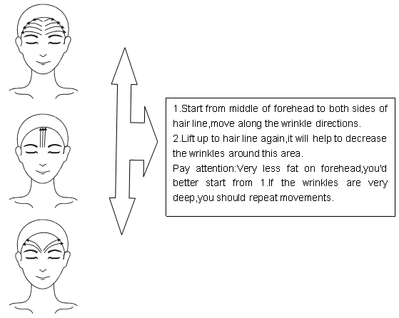
Neck
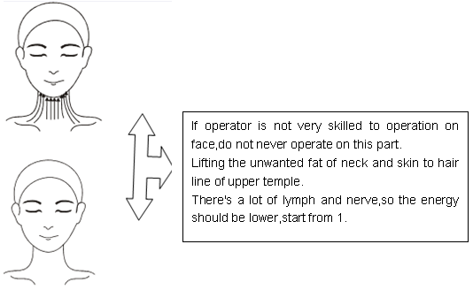

Skin care after treatment
- Use some sunscreen lotion in case of sunburn
- Pay attention to moisturizing skin very often.
- Do not make a lot of face expression in 3 hours after treatment
- Do not never go to hot place,like Sauna, spa.

